Kol Simcha Torah Gazette
For parshas vayetzei 5785
Volume 9 Issue 11 (Whole #425) 6 Kislev 5785/ December 7, 2024
Printed L’illuy nishmas Nechama bas R’ Noach, a”h

For a free subscription, please forward your request to keren18@juno.com
Past emails can be found on the website ShabbosStories.com under Brooklyn Torah Gazette

Shalom Nagar, The Executioner Who Hanged Eichmann, Passes Away
By Wikopedia, the Free Encyclopedia

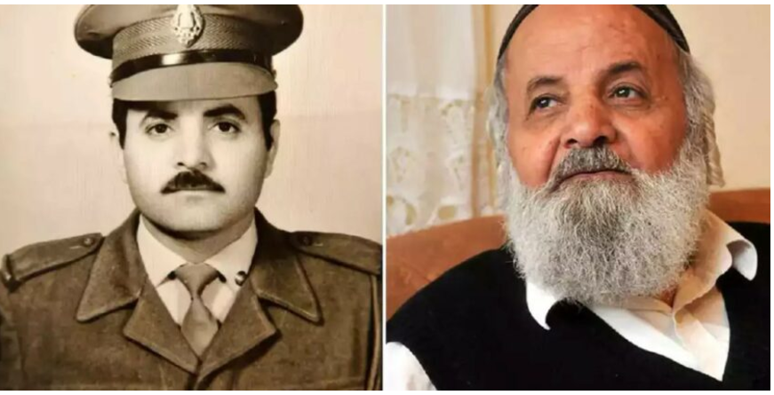

Shalom Nagar (Hebrew: שלום נגר; 1936 or 1938 – 26 November 2024) was a Yemeni-born Israeli prison guard known for executing war criminal and Nazi Party official Adolf Eichmann by hanging. His identity was kept secret for thirty years for fear of reprisals, until it was revealed by journalists in 1992.
Nagar was born in Yemen in the late 1930s. Sources differ as to the exact year: Haaretz and The Times of Israel report his year of birth as 1936 while The Jerusalm Post reports 1938. He moved to Israel as an orphan in 1948.
He came from a religious family, later becoming secular before returning to Orthodox Judaism.^{[3]}
Before joining the Israel Prison Service, Nagar served in the IDF’s Paratroopers Brigade and worked for the border police.
Nagar was working for the Israel Prison Service at Ramle Prison in the early 1960s when war criminal and Nazi Party official Adolf Eichmann was held there during the trial for his role in The Holocaust.
Nagar was one of 22 handpicked "Eichmann guards". The prime minister at the time, David Ben-Gurion ensured that the Eichmann guards were Sephardic, as he felt that Ashkenazi Jews whose families were killed in The Holocaust would be motivated to harm the prisoner. Suicide-watch was a key duty. Nagar was also charged with testing food given to the prisoner, for fear someone would try to poison him. He guarded Eichmann for six months, and was always in the presence of other guards.
After Eichmann's sentencing to death in December 1961, Nagar was randomly selected to carry out the execution. He didn't want the duty, but was convinced to accept it after being shown pictures of Holocaust atrocities against children. In 2005, he told Jewish magazine Mispacha: "It so appalled me that I agreed to do what needed to be done".
Such was the secrecy around the execution that Nagar's commander collected him for the duty by bundling him into a car while he was walking in the street with his wife. Nagar was concerned that she would believe he had been kidnapped, so they returned to say he had been called in as the prison was short staffed.
The execution by hanging took place on sometime between 30 May and 1 July 1962. This was the only judicial execution ever held in Israel. Nagar described arriving at the gallows when Eichmann's already had the noose around his neck and was stood over a trap door. While an official account states that there were two people who pulled a lever simultaneously to carry out the execution, Nagar did not recall anyone else being there. He said he looked into Eichmann's eyes before stepping behind a screen to pull the lever.
After an hour, Nagar took the body down from the scaffold. He said that the loud gasping sound of air being released from the corpse's lungs made him feel that "the Angel of Death had come to take me too".
Afterwards, it was Nagar's job to take the corpse for cremation in an oven symbolically built by a concentration camp survivor. He struggled; his hands were shaking and he had difficulty walking unaided.
Eichmann's ashes were later scattered at sea, beyond Israel's territorial waters. It was planned that Nagar would take them to the port, but he was so traumatized by the hanging that he was escorted home, and a police van transported the ashes. In the following years, Nagar suffered from PTSD and nightmares, and feared Eichmann was following him.
In the 1980s Nagar was asked if he would carry out the execution of Ivan Demjanjuk. He refused, later saying he had "had enough trauma".
Nagar's identity as Eichmann's executioner was kept secret for 30 years due to fear of reprisals, until it was discovered and revealed by journalists in 1992. They had been researching a radio program on the anniversary of Eichmann's death, reviewing prison records and talking to former prison employees. At this time, Nagar was living at Kiryat Arba, an urban Israeli settlement in the West Bank.
He said that he was sworn to secrecy over the execution, but after Mossad chief Isser Harel had published a book about Eichmann's capture he felt he had nothing to fear, saying: "Besides, I was involved in the great mitzvah of wiping out Amalek".
According to the Jewish Herald-Voice, when a German media outlet asked to interview Nagar in 2004 he insisted that the interview take place in his kollel. The paper describes the "Jewish study hall" as being "anything but quiet", with "piles of books scattered all over and loud argumentative voices".
When the German reporter asked why he wanted to be interview in such a noisy environment, Nagar responded that he wanted any television interview, likely to be watched by millions of Germans, to show that the Jewish people were thriving on the values, culture and traditions that "Hitler and Eichmann [...] wanted to decimate".
Nagar was the subject of a 2010 documentary, The Hangman. A German-language novelisation of his story, Nagars Nacht ("Nagar's Night"), has also been published and translated into English as Eichmann's Executioner. Library Journal said of the translation: "The weaving of past with present, fact with fiction brings Eichmann alive and even humanizes him, a feat that impressively expands our understanding of the Holocaust".
Gabriel Erem, writing for Jewish News Syndicate, described Nagar as "soft-spoken" and "pious". Erem described in 2021 hearing of Nagar's poor medical condition and modest home, and rallying descendants of Holocaust families to finance "a suitable, medically supervised, first-rate senior home for the last living hero of an era".
He died 26 November 2024, with reports placing his age at 86 or 88.

Reprinted from Wikopedia, the free encyclopedia.

Rav Avigdor Miller on
How do I Make Peace
With My Mother-in-Law?

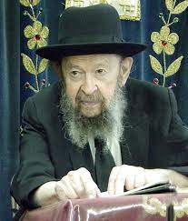
The first step is to send her a little gift. A woman was telling me that she was fighting with her mother-in-law for a long time. So, I said, “Stop talking against your mother-in-law.”
“What can I do?” she said. “She’s my enemy.”
I said, “The first thing is to send her a little gift.” That’s number one. And even if she’s going to belittle you again and she’ll say, “Such a gift she sends me!”, don’t worry. Because she’s going to feel, however, a certain warmth, a softness towards you. מתן אדם ירחיב לו – A man’s gifts open the doors for him (Mishlei 18:16). It’s important to give gifts; small gifts.
A father-in-law was making trouble for someone here in the shul. I said, “Send your father-in-law a seventy-five cents pair of cheap cufflinks. Mail it to him; it’s a good beginning. Don’t think of it as a small thing.” And therefore, מתן אדם ירחיב לו – a man’s gifts open the doors for him. You can make shalom with gifts.

Reprinted from the Parshas Toldos email of Toras Avigdor, - Tape #824.
The Reality of G-d’s Promise
to Jacob of the Ownership
of the Land of Israel
From the Teachings of the Lubavitcher Rebbe
Rabbi Menachem Mendel Schneerson, Zt”l

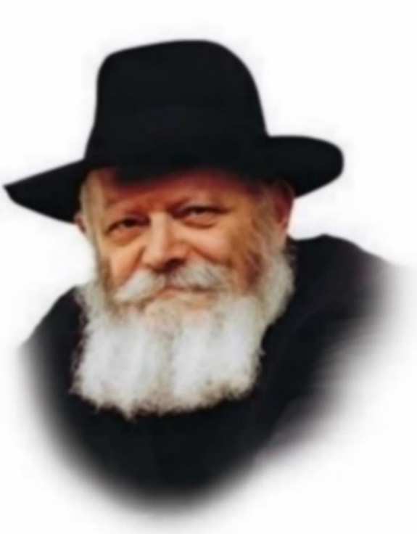

In this week's Torah portion, Vayeitzei, G-d promises Jacob: "I am the L-rd G-d of Abraham your father and the G-d of Isaac; the land on which you lie, to you will I give it, and to your seed."
According to our Sages, "G-d folded up the entire Land of Israel beneath him, thereby hinting that it would be as easily conquered by his descendants as four cubits, which is the area that a person covers." In the same way that conquering a tiny space (the four cubits Jacob occupied when he lay down to sleep) is easy, so too would it be easy for Jacob's children to conquer the entirety of the Land of Israel.
Two generations previously, when G-d promised Abraham that Israel would belong to him and his descendants, He commanded him: "Arise and walk through the land in its length and in its breadth, for I will give it to you." Abraham strode throughout the Land of Israel, visiting any location he wished without interference. He walked through the Land as its "baal habayit" (proprietor), thereby demonstrating his ownership.
G-d's promise was in effect even before Abraham's sojourn. But after he walked the length and breadth of the Land, he was able to more strongly perceive the fulfillment of G-d's words.
Jacob, by contrast, was never commanded to "walk"; it was enough for him to lie down on the ground to sleep. Jacob did not openly demonstrate his ownership of the Land. No one else was present, and thus no one knew that G-d "folded up the entire Land of Israel beneath him."
The innovation in G-d's promise to Jacob (as opposed to His promise to Abraham) was that the Land of Israel would be conquered easily and without effort. You will not have to do anything to obtain it; just lie down on the earth, and it will come into your possession.
G-d promised the Jewish people that they would conquer the Land successfully and effortlessly.
Today, there are some Jews who must still be convinced that the entirety of the Land of Israel belongs to the Jewish people forever. There are some Jews who are not entirely sure of our ownership of the Land.
Nothing is created by G-d without a purpose. No element in the world exists that has no function, nor does G-d do anything "coincidentally" or without significance. If G-d "folded up the entire Land of Israel" to show Jacob that it would easily conquered, He did so because that is the true reality!

Thoughts that Count
for Our Parsha

And he gave him Rachel his daughter to him for a wife (Gen. 28:28)
How did Jacob marry both Rachel and Leah, when the Torah prohibits a man from being married to two sisters at the same time? The lineage of the children of a non-Jew (Laban) is determined by their mother; Rachel and Leah were the daughters of two different women. Accordingly, Rachel and Leah did not have the legal status of sisters. (Bechor Shor)

It is not yet time that the cattle should be gathered together; water the sheep, and go and feed them (Gen. 29:7)
Rabbi Meir of Premishlan used to pray: "Father in Heaven! If it is not yet time to gather the lost flock of Israel in the Final Redemption, at least bless them abundantly from Your full and Holy Hand, that they may be able to anticipate and look forward to Your salvation, may it come speedily in our day.

G-d saw that Leah was hated, and he opened her womb (Gen. 29:31)
G-d forbid that our holy Patriarch Jacob "hated" his wife Leah! Rather, as is often the case among righteous people, Leah was forever critical of herself, always seeking character flaws to improve upon. (Kol Simcha)

This time I will praise the L-rd...and she left off bearing children (Gen. 29:35)
As brought down in the Talmud (Berachot 54), whenever a Jew offers thanks to G-d for the past, he must immediately take the opportunity to pray for the future. However, when Leah thanked G-d for the birth of Judah, she did not do this; thus "she left off bearing children." (The Rebbe of Lublin)

Reprinted from the 5762/2001 Vayeitzei edition of L’Chayim.

Behold, I Am with You

Behold, I am with you; I will guard you wherever you go, and I will return you to this soil; for I will not forsake you until I will have done what I have spoken to you. (28:15)
A chassid once came to R' Yisrael Friedman z"l (the Rizhiner Rebbe; died 1850) for advice. As he waiting his turn to see the rebbe, the rebbe's young son, Dovid Moshe (the future Chortkover Rebbe), approached him and asked him what he wanted.
"I need a yeshuah / salvation," the chassid said.
Young Dovid Moshe replied, "I'll wait here for you. I'd like to know what my father tells you."
A few minutes later, the man emerged and reported, "The rebbe assured me that Hashem will help."
"And what will be until He helps?" the boy asked.
"I really don't know," the man replied helplessly.
"Go back and ask my father," instructed little Dovid Moshe.
The man reentered and repeated the boy's question. Said, the rebbe, "Hashem will also help until He helps. There is proof of this in the Torah. Hashem promised Yaakov that He would not abandon him "until I will have done what I have spoken to you." Does this mean that Hashem will abandon Yaakov after He has fulfilled His promises? Obviously not! Rather, it means that Hashem will not refrain from caring for Yaakov even before He is ready to keep His promises to the patriarch.

Reprinted from the Parshat Vayetze 5785 email of R’ Yedidy Hirtenfeld’s whY I Matter parsha sheet for the Young Israel of Midwood in Brooklyn. (Excerpted from “The House of Rizhin” by Rabbi Menachem Brayer).
Getting Dressed for Shabbos 2.0
By Rabbi Yair Hoffman



Picture the holy Rabbi Elimelech of Lizhensk, known as the No’am Elimelech – a towering 18th-century Chassidic master whose writings and very name reflects the idea of, “Hashem is my king.” This tzaddik, who drew thousands to the path of dveikus Bashem with his profound teachings and personal example, reveals to us a stunning truth about Adam HaRishon’s original state in Gan Eden.
Before the first Aveirah, Adam HaRishon dwelled in pure ruchnius – spirituality, connected to the Etz Chaim – the Tree of Life. Let’s imagine such an existence.
Pure light. Pure spirit. Pure Dveikus to Hashem.
But after the Aveirah, something profound happened – humanity descended into the physical realm, and Hashem clothed Adam and Chava in “garments of skin.”
Here, however, is where matters get interesting.
In Lashon HaKodesh, the word for skin – ‘ohr’ with an ayin – is intimately connected to the word for light – ‘ohr’ with an alef. Do we see the magnificent potential here? Even in our descent, the possibility of growth and ascent was woven into the very garments that we wear.

Every single week, we have the opportunity
To experience this transformation ourselves.
When Erev Shabbos arrives, we don’t just change our clothes – we participate in a cosmic change and elevation. When we remove our weekday clothes, we are not just changing outfits. No.
We are symbolically shedding our physicality, the mistakes, the errors. The ill-treatment of others around us that are a tzelem Elokim and a chailek Elokah mima’al. We shed the mundane concerns of the week.
When we put on our Shabbos clothes – oh, what a moment of sheer kedusha! It is not just a nice suit or a beautiful dress. We are clothing ourselves in garments of Ohr – light! We are connecting ourselves to the Aitz Chaim – the Tree of Life! We are, for these precious 25 hours, elevating ourselves to taste that original spiritual state that existed before any sin, before any cataclysmic descent.

Our Shabbos Clothes Make Us Stand Taller
This is why our Shabbos clothes feel different, why they make us stand taller, feel holier. Because they’re not just clothes – they are spiritual tools or ladders, connecting us to the highest realms of existence and Kedusha.
So today, when we prepare for Shabbos, let us remember that we are not just getting dressed. We are participating in a transformation that echoes from Gan Aiden itself. We are turning skin into light, physicality into spirituality, mundane into Kedusha!
This is the power of Shabbos. This is the magic woven into every thread of our Shabbos garments. May we merit to fully experience this elevation every single week, and may our Shabbos clothes truly become garments of light, illuminating our homes, our communities, and our very souls with the radiance of holiness!
This article is based on the writings of the Noam Elimelech and the Ma’or Vashemesh – Rabbi Kalonymus Kalman Epstein of Krakow. Writing in the late 1700s, his teachings illuminated deepeer meanings of Shabbos for generations to come.

Reprinted from the November 29, 2024 website of Yeshiva World.

The Difference
Are the Tattoos
By Rabbi Joey Haber

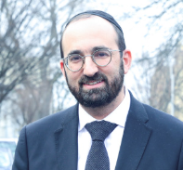

What is the defining difference between us Jews and the surrounding society?
There are several, but if I had to choose one, I would say: the tattoo. The most significant and fundamental difference between us and them is the tattoo.
Why do I say that? True, tattoos are forbidden by the Torah, but so are cheese burgers. So why do I see tattoos as reflecting the defining difference between us and our society, rather than cheese burgers – or the many other things which they do which we don't??
The answer is that the tattoo is permanent, and the young person who gets a tattoo does so without thinking beyond the immediate here-and-now.
People get tattoos of the logos of their favorite sports team – but how do they know that they will still be rooting for that team in thirty years? How do they know that they will even be interested in sports in thirty years?
People get tattoos of dragons and the like on visible parts of their body, like the neck. How do they know that they won't one day seek a high position in a major corporation, where such images are wholly inappropriate?
Of course, the young people who get these tattoos aren't thinking long-term. They like the idea of the tattoo now, so they get it, without taking the future into account.
And this might be the most important distinction between us and them.

We are the eternal nation. This means not only that the Jewish People are guaranteed to exist forever, but that we live each day with an awareness of our future, both individual and collective. We live with an understanding that we are part of a story that began millennia ago with Avraham Avinu, and will continue forever. We cannot focus only the here-and-now. We are always thinking of our future, our legacy, the everlasting impact that we have, and our children and our grandchildren. This "eternity mindset" is one of the defining characteristics of the Jewish experience.

Reprinted from the Parashat Toldot 5785 email of Rabbi David Bibi’s Shabbat Shalom from Cyberspace.

41st Annual International Conference of Chabad-Lubavitch Emissaries
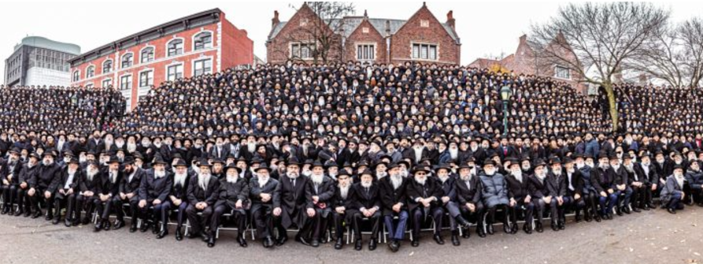
The photo, taken on Sunday, December 1, 2024 under the iconic gables of 770 Eastern Parkway, Chabad headquarters in Brooklyn, N.Y., features almost five thousand black-hatted rabbis and represents not just an annual conference tradition—it has been captured since 1984—but also the many faces of Chabad rabbis who bring Judaism to the world. Rabbis from war-torn Ukraine to ones stationed in the towns along Israel’s hostile borders; rabbis serving college campuses across the United States to those bringing Judaism to communities that have sprung up in the Southwest. All posed in a portrait of Jewish pride and unity.
Reprinted from the current website of Chabad.Org

